##### Northeast Decision Sciences Institute

## **2013 Annual Meeting: April 5-7, 2013**

New York Marriott at the Brooklyn Bridge, Brooklyn, NY

**Call for Papers Deadline: October 26, 2012**

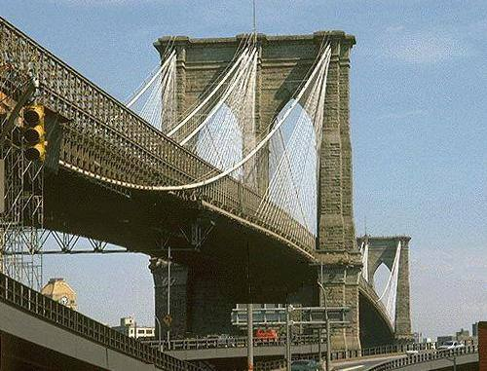

#### MEETING ANNOUNCEMENT

The 2013 Annual Meeting of the Northeast Region of the Decision Sciences Institute will be held April 5-7, 2013 at the NY Marriott at the Brooklyn Bridge Hotel in New York.

### CALL FOR PAPERS

Competitive papers or proposals for papers, symposia, tutorials and workshops are invited for, but not limited to, the topic areas listed below. Sessions involving practitioners will be given special consideration. Submissions will be blind refereed and accepted papers will be published in the Conference Proceedings. By submitting a manuscript, the author certifies that it is not copyrighted or previously published, has not been presented or accepted for presentation at another professional meeting, and is not currently under review for presentation at another professional meeting. At least one of the authors certifies that he/she intends to register for and attend the conference to present the paper if it is accepted. **All papers and proposals must be submitted electronically on or before October 26, 2012.**

### PROGRAM TRACKS

* Accounting
* Analytics/Business Intelligence/Data Mining
* Asian Studies/International Business
* Business Law/Ethics/Corporate Social Responsibility
* Case Development and Teaching
* Crisis Management-IT and Other Perspectives
* Economics, Finance and Financial Management
* Information Technology/Information Systems
* Innovative Education
* MS/OR Techniques, Models, & Applications
* Manufacturing Operations Management
* Marketing and E-Commerce
* Organizational Theory, Behavior and Human Resources
* Quality Management and Lean Operations
* Services and Health Care Management
* Social Media
* Statistical Theory & Applications
* Strategy and Policy
* Supply Chain Management
* Sustainability

### OUTSTANDING PAPER AWARDS

Outstanding papers are eligible for the following awards:

* Robert Pearson Memorial Award: *Best Application of Theory*
* Robert Pearson Memorial Award: *Best Contribution to Theory*
* David M. Levine Award: *Best Paper in Education*

### INSTRUCTIONS FOR CONTRIBUTORS

All papers and proposals must be submitted using the Web-based submission system found at the following link: <http://www.conferencemgt.com/conf/NE13.html>.  You will need your paper or proposal, *excluding author identification*, **in PDF format** and information for all authors including full name, affiliation (business or university) mailing address, office phone, and e-mail addresses.  Detailed instructions can be found on the website.

Papers and proposals should be double-spaced. Regular paper submissions should not exceed 20 pages in length. Paper proposals should be as complete as possible and include preliminary findings and justification for the effort. Two pages is a guideline for communicating this information to the reviewer so that s/he may do a credible job. All information identifying the authors should be removed from the paper and the title page should show only the title of the paper.

Accepted papers must be formatted in final condensed form and returned to the Proceedings Editor by January 23, 2013. Specific instructions will be sent to the authors with the acceptance notification.

### HOTEL ARRANGEMENTS

The NY Marriott at Brooklyn Bridge has provided a limited number of rooms at the special conference rate of $239 per night, single or double, plus tax; available from April 4-7. For reservations call 1-800-228-9290 before March 4, 2013 and state that you are attending the NEDSI Meeting.

**OFFICER NOMINATIONS**

The NEDSI Nominations Committee welcomes nominations for board members and officers. Contact Minoo Tehrani via email at mtehrani@rwu.edu.

**CONTACT INFORMATION**

John F. Affisco, 2013 NEDSI Program Chair

Dept. of IT/QM, Zarb School of Business

Hofstra University

Hempstead, NY 11549-1340

516-463-5362 (voice mail) 516-463-4834 (FAX)

[nedsi13@conferencemgt.com](mailto:nedsi13@conferencemgt.com)  
[John.F.Affisco@hofstra.edu](mailto:John.F.Affisco@hofstra.edu)