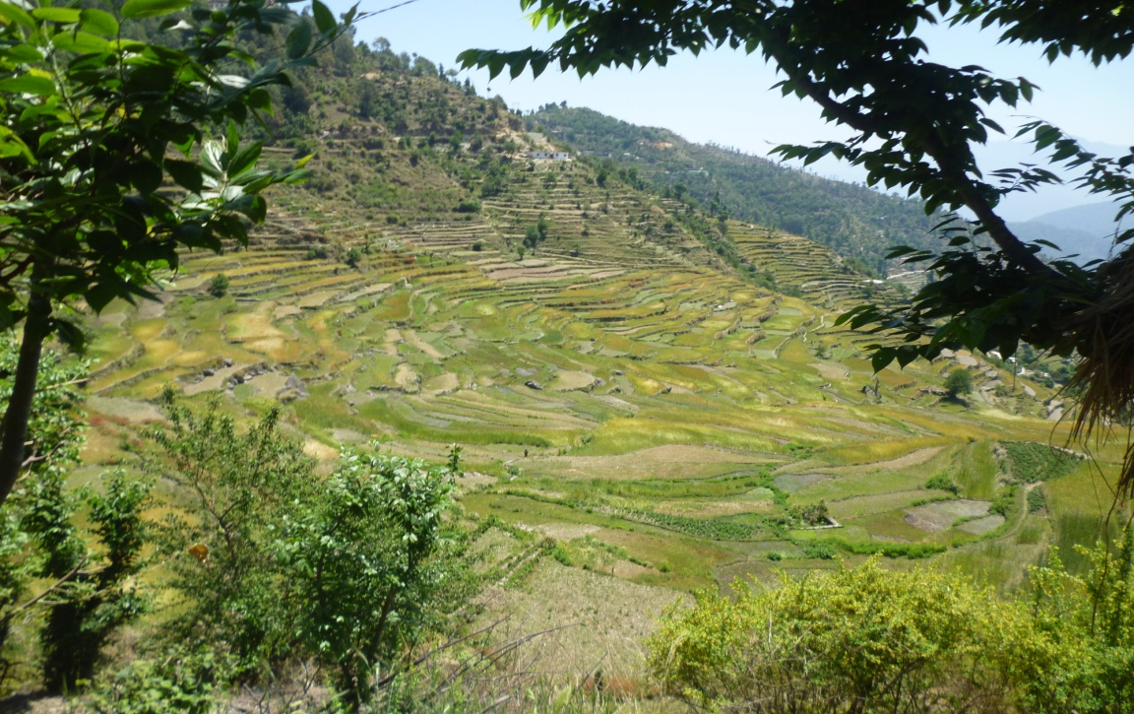

Figure 1: Panoramic view of agriculture fields in study area

Figure 2: Land use pattern of the district Rudraprayag

Figure 3 : Monthly income of farmers in the surveyed villages by polyhouse adoption

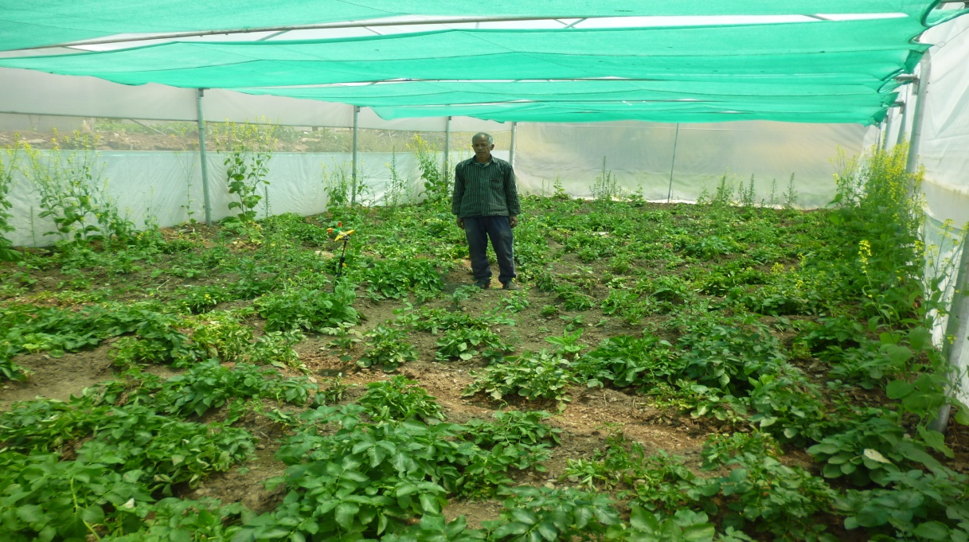
Figure 4 : Potato cultivation during winters within polyhouse for protecting crop from frost and wild animals in a high altitudinal village Dhankurali
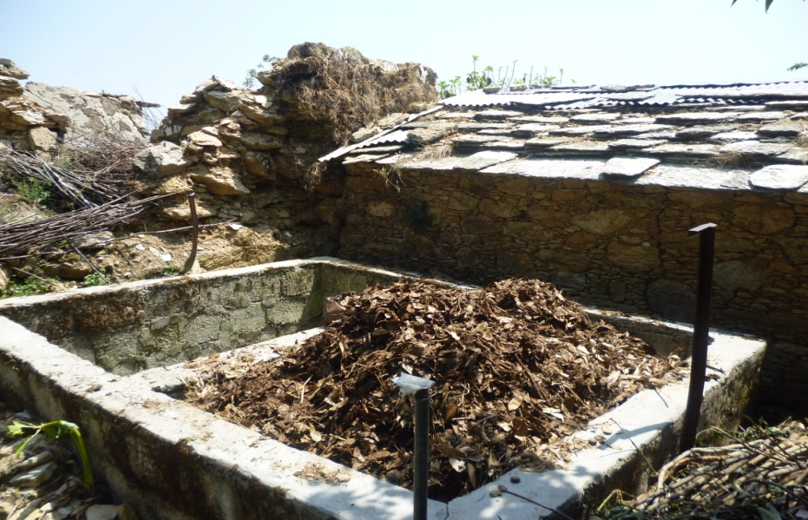
Figure 5 : Vermicompost preparation in village Dhankurali

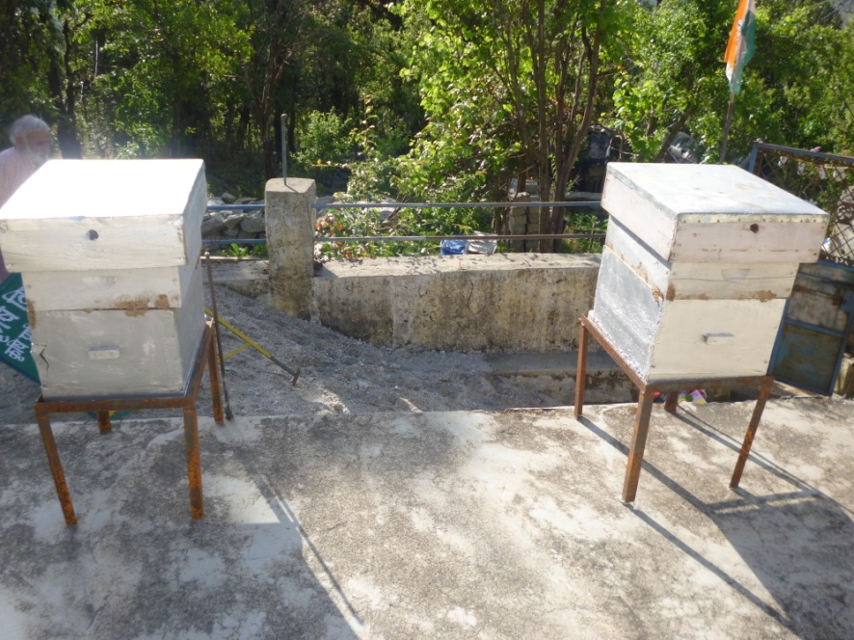
Figure 6 : Bee-keeping in village Talli-Jakhwari
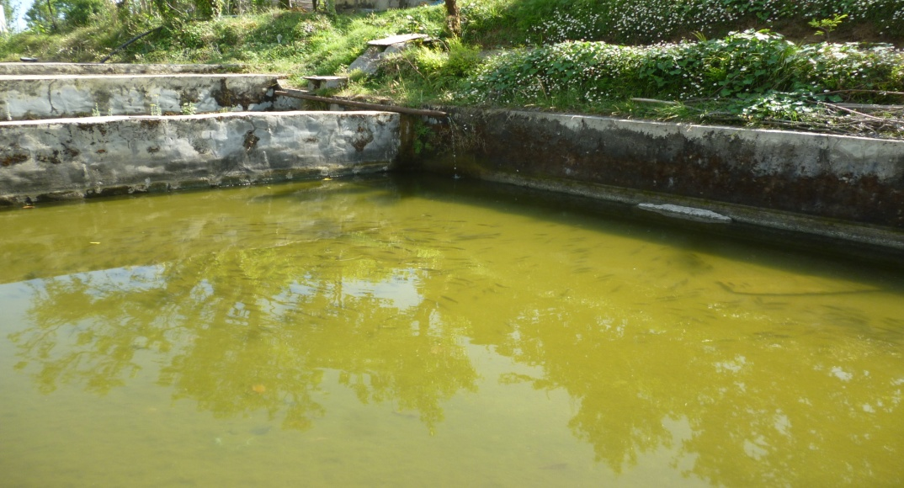
Figure 7 : Fish pond in village Kapniya

