Association For Information Systems
Special Interest Group on ICT and Global Development
http://www.globdev.org/

Our Vision
To contribute to progress in the economically developing communities of the world through the appropriate use and diffusion of ICT and associated information management practices.
We aim to contribute significantly to tackling the problem of global poverty and the global divide through its educational and research activities. We are guided by concepts of Development through which we can assess outcomes from the use of ICTs in underserved communities.

Challenge
Approximately half of the world’s people are unable to sustain themselves- a situation, which is untenable from a humanitarian viewpoint and a threat to global peace and environmental stability. Information and Communications Technologies (ICT) can play an important role in alleviating this situation. New wireless technologies, for example, do not require massive investments in infrastructure and can enable communications, e-government, and telemedicine to be brought to even the most distant and impoverished populations.

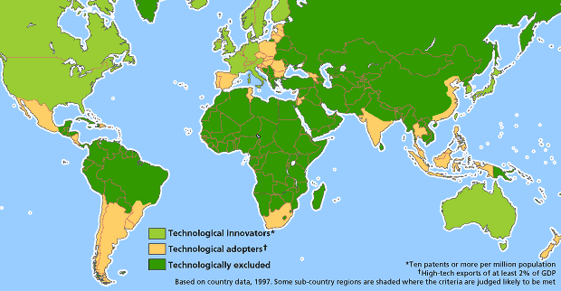

*image: http://www.economist.com/node/80730

Research Activities
- Develop proposals for funding of SIG projects by industry, gov’t, and NGOs
- Scholarly exchange between universities in economically developing and developed countries – faculty and PhD students
- Conduct case studies and perform action research relating to ICT interventions in economically developing countries using partnerships between faculty and PhD students in both economically developed and developing economies.

Global Development Workshops
- In addition to the track at AMCIS, Global Development Workshops are held at ICIS and ECIS. Global Development workshops address questions that provide new and meaningful definitions of Development, such as, Can ICTs support the development, promotion and realization of a model of development that is holistic, inclusive, just and sustainable, and that will lead to an appropriate quality of life for each individual on the planet?
Educational Activities
- Design and assist the implementation of PhD programs in developing economies using the program at Addis Ababa University, with which several AIS member are involved, as a model
- Support the “Global Text Project” – develop open source text books and case studies in management, entrepreneurship, economic development and ICT implementation
- Develop opportunities for short educational seminars, online courses, and online certificate and degree programs
- Graduate student studies abroad program to build educational capacity

AMCIS MINITRACK 2017
Joins us in Beacon D
Friday, Aug 11 1:30 - 3
Saturday, Aug 12 8:30 - 10
Saturday, Aug 12 10:30 - 12
Saturday, Aug 12 1:30 - 3
Saturday, Aug 12 3:30 – 5

SIG GlobDev Officers
President: Sajda Qureshi, University of Nebraska at Omaha, USA squreshi@unomaha.edu
VP Research: Arlene Bailey, University of the West Indies, Mona, Jamaica arlene.bailey@uwimona.edu.jm
VP Education: Kirstin Krauss, Rhodes University, South Africa k.krauss@ru.ac.za
Treasurer: Ted Stohr, Stevens Institute of Technology, USA estohr@stevens.edu
Secretary: Philip F. Musa, The University of Alabama at Birmingham, USA musa@uab.edu
VP Membership: Monica Garfield, Bentley University, USA mgarfield@bentley.edu
VP Communications: Heinz Roland Weistroffer, Virginia Commonwealth University, USA hrweistr@vcu.edu
Webmaster: Salam Abdallah, Abu Dhabi University, UAE salam.abdallah@adu.ac.ae
AIS eLibrary Proceedings Manager: Jie (Jason) Xiong, University of Nebraska Omaha, USA xiongjj@appstate.edu
AIS Community site moderator/coordinators: David Nemer, School of Information Science, University of Kentucky, USA david.nemer@uky.edu

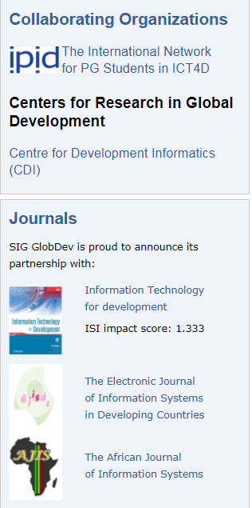

Membership:

SigGlobDev Membership is available for a small fee through the AIS web site: http://aisnet.org/?SpecialInterestGroup

