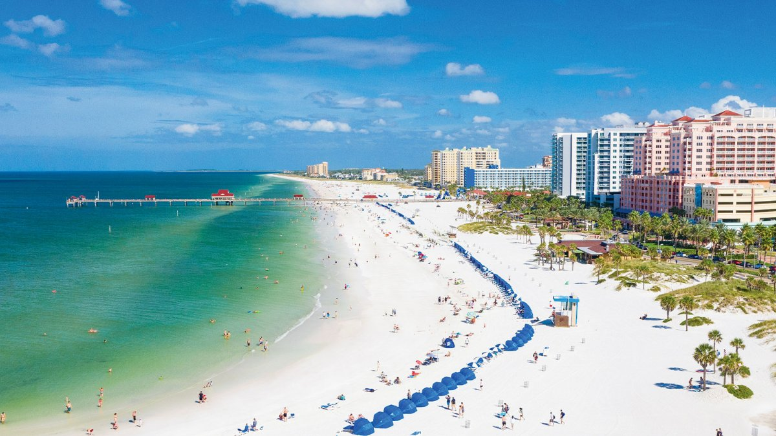

**23-25 May 2016**

**Call for Papers – DESRIST 2022  
St. Petersburg, FL, USA  
1-3 June 2022**<https://desrist2022.org>

<https://desrist2022.org>

**Conference Theme and Tracks – The Transdisciplinary Reach of Design Science Research (DSR)**

Today’s world faces many complex challenges (i.e. wicked problems) that offer no easy solutions. Inter-related economic, environmental, social, political, and ethical drivers emphasize the need for a changing research landscape quite different from the disciplinary framing found in current institutional structures and processes. Design Science Research provides a compelling frame for transdisciplinary projects with its unique mix of creative design to solve relevant problems and rigorous science to grow theory around the intervention and use of the novel solutions. Transdisciplinary research tracks include:

|  |  |
| --- | --- |
| * **Theme Track – Transdisciplinary Research** * **FinTech and Blockchain Systems** * **Intelligent Systems and Human-Computer Interaction** * **Healthcare Systems and Quality of Life** * **Innovation and Entrepreneurship** | * **Sustainability and Responsible Design** * **Human Safety and Cybersecurity** * **Emerging DSR Methods and Processes** * **Designers and Collaborative DSR** * **Education and DSR** |

**Venue**

DESRIST 2022 will be located on the University of South Florida (USF) St. Petersburg campus. The urban campus combines natural beauty with the appeal of city life. You are within walking distance to world-class museums and dining options in a vibrant and dynamic downtown. Dubbed the “Sunshine City,” St. Petersburg is home to some of the world’s best beaches with access to many attractions throughout the State of Florida.

**Key Dates**

* Deadline for Full paper and Research In Progress (RIP) paper submissions: 1 February 2022
* Paper reviews due: 7 March 2022
* Notification of paper acceptances: 14 March 2022
* Deadline for Prototype, Panel, Tutorial, and Workshop submissions: 14 March 2022
* Camera ready paper submissions: 28 March 2022
* Notification of Prototype, Panel, Tutorial, and Workshop acceptances: 18 April 2022
* Research summary for the doctoral consortium: 18 April 2022
* Notification of doctoral consortium acceptances: 25 April 2022

**Conference Chairs:** Matthew Mullarkey – University of South Florida

Alta van der Merwe – University of Pretoria

**Program Chairs:** Alan Hevner – University of South Florida

Aurona Gerber – University of Pretoria

Andreas Drechsler – Victoria University of Wellington