**Call for papers: Special Issue of Production and Operations Management on “Responsible Data Science”**

# Guest editors

Maxime C. Cohen; Desautels Faculty of Management, McGill University

Nina Huang; Miami Herbert Business School, University of Miami

Meng Li, Paul A. Pavlou; C. T. Bauer College of Business, University of Houston

**Submissions open:** August 1, 2022

**Deadline:** ~~November 30, 2022~~ (Revised Deadline: January 31, 2023)

# Motivation

Our society is experiencing a rapid digital transformation, changing the way how different players in supply chains and technological systems interact with each other and exert their influences. For example, the way that businesses and customers interact has changed in the digital economy with the influence of computing technology and information sharing. Businesses now routinely collect large volumes of fine-grained data to analyze consumers’ behavior, and consumers can also track changes in firms’ strategies to make informed purchasing decisions. An iconic trend in the era of digital transformation is the increasingly extensive use of data analytics and machine learning tools in decision making as both strategic and operational levers.

The use of rich and large data sets also raises critical societal concerns. For example, data sets often include personal sensitive information that can be exploited, without explicit knowledge and/or consent from the involved individuals, for various purposes including monitoring, discrimination, and illegal activities. On the one hand, data- and AI-driven algorithms may have created a competitive advantage for firms that are using these algorithms. For example, large corporations can create unequal competition in the market against smaller players. Similarly, firms may attract customers with stronger financial records by offering personalized enticing incentives, leading to a social bias toward individuals who are offered fewer appealing opportunities. On the other hand, algorithms that do consider social inclusion and fairness considerations have a great potential to reduce the inequalities induced by social status, gender, and race, just to name a few.

Responsible data science is defined as the utilization and exploitation of data via manual analysis or automated algorithms (such as machine learning) that aim at improving the terms of participation in society, particularly for individuals or corporate entities that are disadvantaged. Such societal participation improvements include, but are not limited to, enhanced opportunities, increased access to resources, and greater voice and respect for human rights.

# Call for submissions

This special issue aims to attracting submissions that are closely connected to real-world operational problems and have the potential to impact practice from the lens of responsible data science. All submissions must have clear managerial or theoretical contributions, and must be

built upon rigorous research methods that serve as an appropriate framework to analyze problems: including analytical modeling, econometric analysis, field experimentation, and behavioral theories.

*All submissions must contribute to the operations management literature and practice*. Areas of focus include the following:

* Algorithmic bias in search and recommendation
* Price discrimination
* Social inequality
* Gender and racial inequality
* Corporate inequality and corporate social responsibility
* Discrimination in resource allocation or hiring
* Workforce relationships
* Inclusive healthcare
* Fairness, accountability, and explainability in AI
* AI standard and regulation
* Privacy concerns in data science and decision-making
* AI ethics

To fit the mission of this special issue, submitted papers should have a solid scientific foundation and fit into one or more of the following categories:

* Analytical: Papers well-grounded in frameworks that fall under the category of social inclusion, ethics, fairness, and privacy.
* Empirical: Papers that use public data, proprietary data, or experiments to test theories related to social inclusion, ethics, fairness, and privacy.
* Technical: Papers that develop or improve upon algorithms that address social inclusion, ethics, fairness, and privacy.
* Multimethod: Papers that combine different quantitative methods mentioned above or qualitative approaches, such as case studies and interviews, for triangulation purposes.

# Submission process

Papers should be submitted through the POM manuscript central website: [https://mc.manuscriptcentral.com/poms.](https://mc.manuscriptcentral.com/poms) Specifically, please follow the prompts below:

On the author tab, please choose “Special Issue Article” (see the image below) in **Step 1**

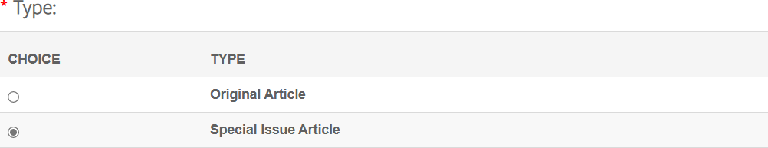

In the drop-down menu (see the image below) that then appears in Step 1, please select appropriate department editor: Special Issue on Responsible Data Science.

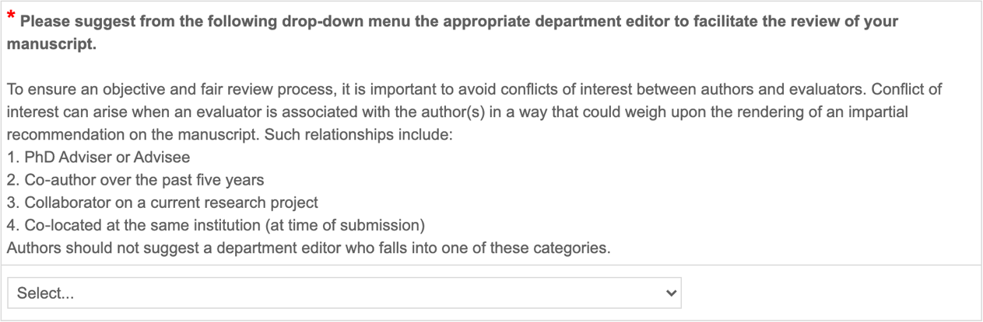

For Step 6, please upload a cover letter that includes the title of the special issue and the specific article type you are submitting. Towards the end of Step 6, please indicate “**yes**” for the question “**Is this submission for a special issue?**” and enter the title of the special issue in the text box below: “Responsible Data Science.”

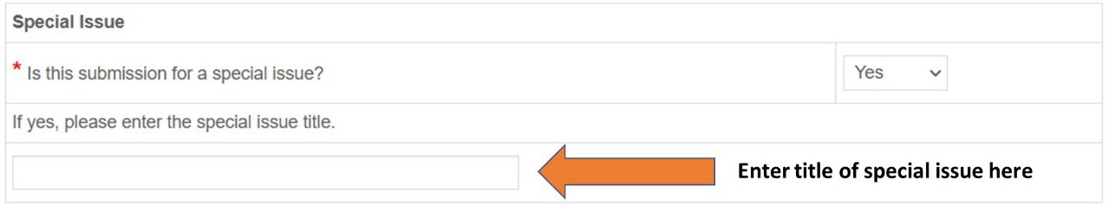

# Submission guidelines

* All papers must conform to the POM’s submission guidelines, which can be found at [https://www.poms.org/journal/author_instructions.](https://www.poms.org/journal/author_instructions/)
* All authors need to follow the ethical guidelines, which can be found at https://[www.poms.org/2021/05/poms_ethical_guidelines_for_au.html.](http://www.poms.org/2021/05/poms_ethical_guidelines_for_au.html)
* We do not allow resubmission of a rejected paper in the same department or a different department of the journal. Also, the paper rejected in a special issue cannot be resubmitted to the regular issue (and vice-versa).
* All papers by authors that have a conflict of interest with either of the special issue editors will be handled by the Editor-in-Chief and others, not by the special issue editors.

# Projected Timeline

* Submissions will be accepted starting from August 1, 2022.
* First submission deadline: ~~November 30, 2022~~ (January 31, 2023).
* Workshop on invited papers: ~~May 2023~~ (June 2023).